Leveraging CNNs: MobileNet and InceptionV3 for Skin Disease Diagnosis

Mr.G.Muthugurunathan
dept. of CSE
Madanapalli Institute of Technology and Science Madanapalli,India muthugurunathang@hotmail.com

A.Venkatesh
dept. of CSE
Madanapalli Institute of Technology and Science
Madanapalli, India avenky0707@gmail.com

M.Manjunath
dept. of CSE
name of organization (of Aff.) Madanapalli, India viratmanju34@gmail.com

M.Yoganand Kumar
dept. of CSE
Madanapalli Institute of Technology and Science
Madanapalli, India kumaryoganand4@gmail.com

S R Thoshith Reddy
dept. of CSE
name of organization (of Aff.) Madanapalli, India thoshithreddy27@gmail.com

Abstract—This project focuses on the development and imple- mentation of a deep learning-based system for the classification of skin diseases using image data. Leveraging powerful pretrained models such as MobileNetV2, EfficientNet, and InceptionV3, the system utilizes transfer learning to extract relevant features from skin disease images. The model employs a stacking approach, combining the predictions from these individual models to improve overall classification accuracy. The system was trained and evaluated on a labeled dataset containing images of various skin conditions, achieving an accuracy of 98%. This research demonstrates the potential of deep learning and ensemble techniques in the medical field, specifically in automated skin disease diagnosis. The project also highlights the significance of leveraging pretrained models and their efficient application in real-world medical image classification tasks. Future work will focus on expanding the model’s capabilities by incorporating additional diseases and improving its deployment for practical use in healthcare environments.

Introduction
Despite the common occurrence of skin disease among people, many individuals do not consult a physician or an expert regarding their skin conditions [1]. Skin diseases were responsible for more than 98,000 deaths worldwide and about 5 billion incidents in 2019. Skin diseases can also lead to disabilities, contributing to a decline in quality of life and life expectancy. The measure of years lost due to disability or low health is measured using a metric called Disability Adjusted Life Years (DALY), which quantifies the burden of a disease.In terms of DALY, skin diseases were responsible for 1.79% of the global burden of diseases in 2019 and remain a major cause of lifelong disability. Table 1 below indicates the increasing incidents and elevation in the number of DALY s and deaths due to skin diseases globally over the years, as collected from the Global Burden of Disease Study.
Many approaches to skin disease detection have been im- plemented over the years; however, there are a few limitations that would have to be overcome to create a better system. The majority of existing solutions studied during the development
of this system utilized a small dataset of images for training the deep learning models. A smaller dataset is more prone to lower precision and accuracy due to under fitting and may not provide enough data to the model for a robust system. Another limitation of a few of the studied systems is that they were only built to detect a small number of skin diseases, decreasing their robustness. A few of the other systems are not capable of handling environmental and texture-based changes in the input image, which is a major factor as the environment and light- ing conditions cannot always be controlled.Apart from this,a few systems were making use of models that may not be powerful enough to understand and detect from a comprehensive list of skin conditions. The vast number of skin diseases [2], coupled with the challenges posed by varying environments and small datasets, makes skin disease classification a critical issue. The applications of deep learning have branched out into various domains, and one of them is healthcare. Deep learning in healthcare is an emerging domain owing to the better quality of healthcare that can be afforded by the implementation of deep learning-based approaches [3].The applications of deep learning have branched out into various domains, including healthcare [4]. Deep learning in healthcare is an emerging field that can improve the quality of healthcare through automation and precision [5]. Some of the applica- tions of deep learning include image analysis, data analysis of healthcare records, and drug discovery [6].Deep learning systems built for detecting skin diseases could aid patients and doctors by increasing the chances of early diagnosis, which allows for timely treatment to prevent mortality and decrease the chances of complications or dis- ability. Skin diseases can be detected based on their visual features, suggesting that a deep learning model could classify skin diseases from images [7]. This technology can assist medical professionals in making better decisions and allow patients to perform preliminary analysis at home, reducing the risk of a fatal outcome.A more accessible and robust system would help

bridge the gap between medical facilities and professionals, making di- agnosis more reliable and accurate [6]. The primary objectives of developing the deep learning system include: • Using a comprehensive dataset that adequately covers a wide range of skin diseases. • Enabling the detection of multiple skin diseases, enhanc- ing its application in medical diagnosis.
- Achieving high classification accuracy to ensure depend- ability in real-world use.
The proposed system has applications in medical environ- ments, assisting healthcare professionals in diagnosing skin diseases. An appreciable Top-5 accuracy demonstrates the effectiveness of the system in guiding professionals by pro- viding a list of highly probable diseases, aiding in correct diagnosis.The project focuses on detecting and classifying skin dis- eases using deep learning techniques. It utilizes a dataset containing various skin disease categories such as cellulitis, athlete’s foot, chickenpox, and others . The workflow consists of:
  - Data Preprocessing: Images are resized and prepared for training using libraries like OpenCV and PIL.
  - Model Development: A neural network model is im- plemented using TensorFlow and Keras to classify diseases accurately
  - Visualization: Matplotlib is used for dataset analysis and model performance evaluation [7].

PROPOSED METHODOLOGY
- Data Collection and Prepocessing
Images of various skin diseases are collected from prede- fined directories, resized to 224x224 pixels, and normalized to ensure uniform input for the model.Labels are assigned to each category for supervised learning.The Project leverages a dataset containing images of various skin diseases for training, testing, and validating a machine learning model. The dataset plays a critical role in ensuring the accuracy and reliability of the classification task. It includes labeled data where each im- age is associated with a specific disease category. The dataset consists of images of skin diseases grouped into different types namely Cellulitis, Impetigo, Athlete’s Foot, Nail Fungus, Ringworm, Cutaneous Larva Migrans, Chickenpox, Shingles. The images are stored in a directory structure, grouped by disease type,like Commonly .jpg or .png.Consists of images used to train the model to recognize patterns associated with different skin conditions.Images are resized to 224x224 pix- els.Converted into numerical arrays using the OpenCV library (cv2).Separate set of images used to evaluate the performance of the trained model.Helps in measuring accuracy, precision, recall, and other metrics.Images are normalized(scaled be- tween 0 and 1) to improve the performance of the neural network.
- Model Development
  - MobileNetV2: MobileNetV2, a lightweight deep learn- ing model, was employed for feature extraction in skin dis- ease classification. The model was initialized with pretrained weights and fine-tuned using a dataset of skin disease images.
Images were resized to 224×224 pixels and normalized before being input to the model. The extracted features were passed through fully connected layers to classify skin conditions. The model was trained using the Adam optimizer with sparse categorical cross-entropy loss. Evaluation metrics, including accuracy and confusion matrices, validated its performance. MobileNetV2 achieved high classification accuracy, making it suitable for real-time skin disease diagnosis.
  - EfficientNet: EfficientNet was utilized as a feature ex- tractor in the skin disease classification model. The model was pretrained on ImageNet and fine-tuned for the specific task. It efficiently processed input images of size 224x224, optimizing feature extraction while maintaining computational efficiency. Transfer learning was applied by freezing the base layers and training additional dense layers for classification. The model was trained using the Adam optimizer and categorical cross-entropy loss function. Performance evaluation included accuracy, confusion matrix, and classification reports, achiev- ing high accuracy. The results demonstrated EfficientNet’s effectiveness in improving skin disease diagnosis.
  - InceptionV3: The InceptionV3 model plays a crucial role in this project by serving as a feature extractor for skin disease classification. The model, pretrained on ImageNet, is fine-tuned by replacing its top layers with custom dense layers to adapt to the specific skin disease dataset. Initially, input images are resized to 224×224 pixels and normalized for consistency. The preprocessed images are then passed through InceptionV3’s convolutional layers, which extract hierarchical features capturing patterns relevant to skin dis- ease classification. A global average pooling layer reduces dimensionality, followed by fully connected layers that refine the extracted features. Dropout regularization is applied to prevent overfitting, and a final softmax layer classifies images into predefined disease categories. The model is trained using categorical cross-entropy loss and the Adam optimizer to enhance accuracy. Evaluations using a confusion matrix and classification reports demonstrate InceptionV3’s effectiveness in identifying various skin diseases with high precision and recall.
- Stacked Ensemble Learning
he stacked ensemble learning approach in this project combines multiple pretrained deep learning models—MobileNetV2, EfficientNet, and InceptionV3—to enhance skin disease classification accuracy. Each model extracts relevant features from input images, and their individual predictions are collected. These predictions are then concatenated and fed into a meta-classifier, which learns how to optimally combine them for final classification. The stacking process allows the system to leverage the strengths of each model while reducing their weaknesses, resulting in improved generalization. The entire model is trained using labeled skin disease images and optimized using techniques like dropout regularization and sparse categorical cross-entropy loss. Performance evaluation is conducted using accuracy metrics, confusion matrices, and

classification reports. This ensemble strategy significantly enhances classification reliability, making it more suitable for real-world medical applications.

- Training and Evaluation

This model is trained using labelled images. During training, the model adjusts its parameters in the meta-classifier layer to improve prediction accuracy based on the input features from the pretrained models.After training, the model is evaluated on test data using a classification report (accuracy, precision, recall, F1-score) and a confusion matrix to visualize prediction accuracy across each skin disease category. This helps identify any misclassification patterns and assess the model’s robust- ness.After training, save the entire stacked model (including the pretrained models and meta-classifier) in a .h5 or .pkl file format. This allows the model to be loaded directly into the deployment environment.Ensure that the saved model can be loaded in the Flask application to handle incoming predictions.
The final model is an ensemble of the three pretrained mod- els (MobileNetV2, EfficientNet, and InceptionV3), combined through a stacking method, which improves the robustness and performance of the classification system.
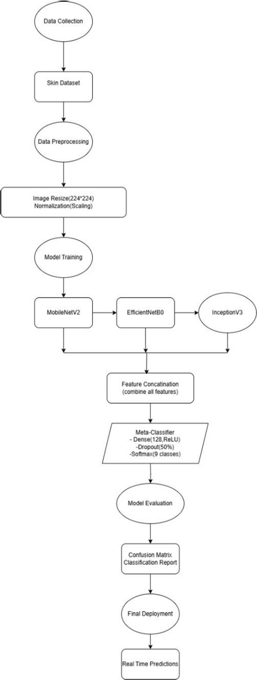
Fig 1:Block Diagram of proposed system
- RESULTS AND DISCUSSION
- Model Training and Validation Performance:
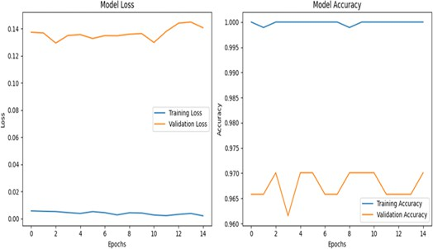
Fig 2:Model Training and Validation Performance of MobileNetV2
The training and validation performance of MobileNetV2 shows a decreasing trend in both loss curves, indicating effective learning. The accuracy plot demonstrates high training accuracy with stable validation accuracy, suggesting good generalization. These results confirm that MobileNetV2 efficiently captures features while maintaining robust performance.
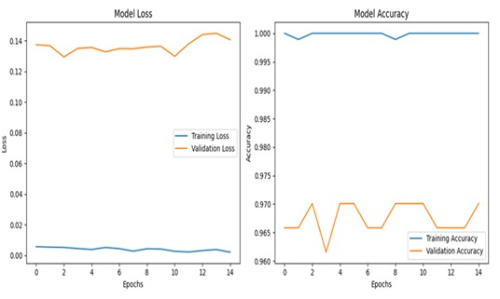
Fig 3:Model Training and Validation Performance of EfficientNet
The training and validation performance of the EfficientNet architecture shows consistently low training loss and high accuracy. However, the fluctuating validation loss and accuracy indicate potential overfitting or instability in generalization.
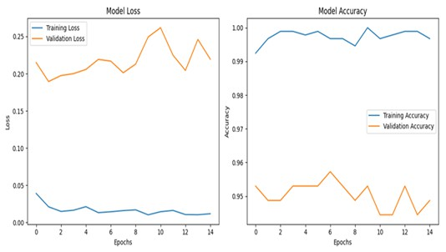

Fig:4 Model Training and Validation Performance of InceptionV3
The training and validation performance of the InceptionV3 architecture is illustrated, showing model loss and accuracy trends over epochs. The left plot indicates consistently low training loss but higher and fluctuating validation loss, suggesting overfitting. The right plot shows high training accuracy with relatively lower and unstable validation accuracy, highlighting potential generalization issues.
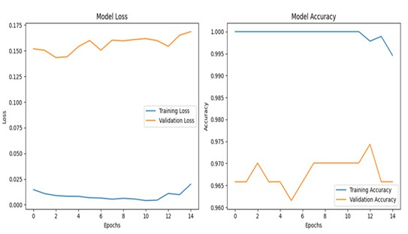
Fig:5 Model Training and Validation Performance of Stacking Classifier
The training and validation performance of the Stacking Classifier architecture is presented, showing loss and accuracy trends over epochs. The left plot indicates a low and stable training loss, while validation loss remains high and fluctuates, suggesting overfitting. The right plot shows near-perfect training accuracy with lower and inconsistent validation accuracy, highlighting potential generalization issues.
- Confusion Matrix for Model Performance:
The image represents the confusion matrix visualizing the performance of the classification model. Rows (Truth): Actual labels of the dataset. Columns (Predicted): Labels predicted by the model.
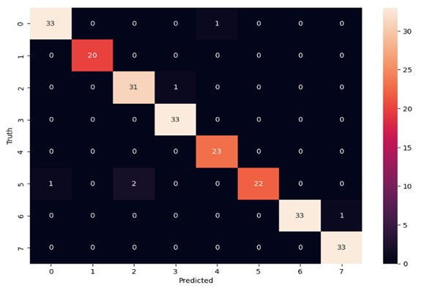
Fig:6 Confusion Matrix for MobileNetV2
The confusion matrix for the MobileNetV2 model illustrates classification performance across eight classes. The strong diagonal dominance indicates high accuracy, though minor misclassifications are observed in certain classes. The
presence of off-diagonal values suggests occasional prediction errors, requiring further optimization for improved robustness.

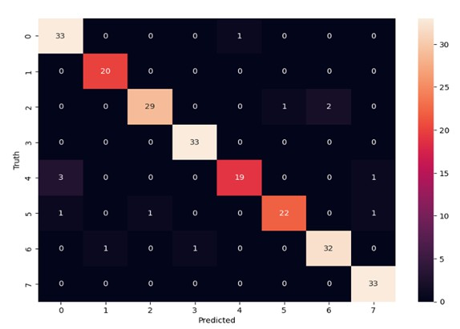
Fig:7 Confusion Matrix for EfficientNet
The confusion matrix for the EfficientNet model demonstrates strong classification performance, with most predictions aligning along the diagonal. Some misclassifications are observed, particularly in classes 2, 4, and 6, indicating areas for potential improvement. The overall accuracy remains high, but further tuning may enhance precision and reduce errors.
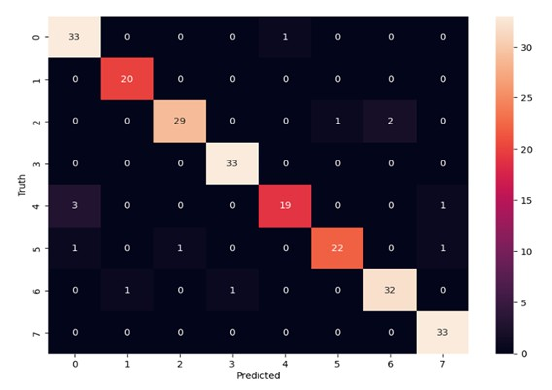
Fig:8 Confusion Matrix for InceptionV3
The confusion matrix for the InceptionV3 model shows strong classification performance, with most predictions correctly aligned along the diagonal. Some misclassifications occur in classes 2, 4, and 6, suggesting potential areas for model refinement. While overall accuracy is high, further optimization may improve precision and reduce classification errors.
Fig 9:The confusion matrix illustrates the performance of a stacking classifier, showing the number of correct and misclassified instances for each class. The diagonal elements represent correct predictions, while off-diagonal elements indicate misclassifications. The color intensity reflects the frequency of occurrences, with higher values shown in lighter shades.

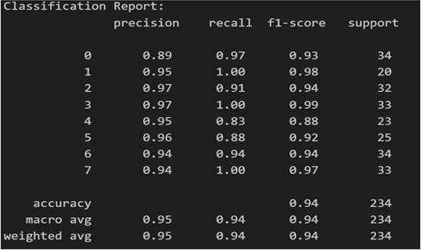

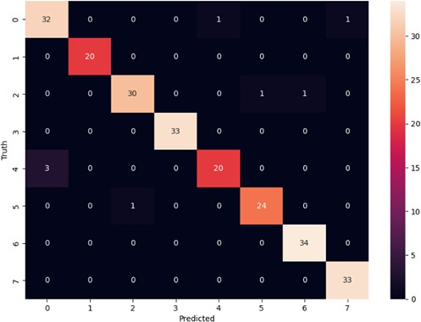
Fig:9 Confusion Matrix for Stacking Classifier

- Classification Report for Model Evaluation:
The image displays a classification report summarizing the performance metrics of the trained model.
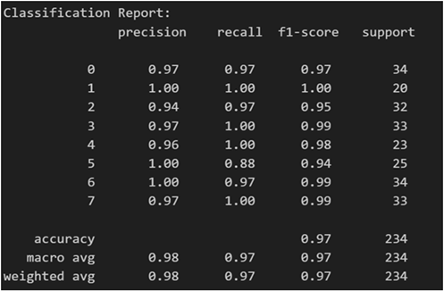
Fig:10 Classification Report for MobileNetV2
The classification report for MobileNetV2 demonstrates an overall accuracy of 97% across 234 test samples.
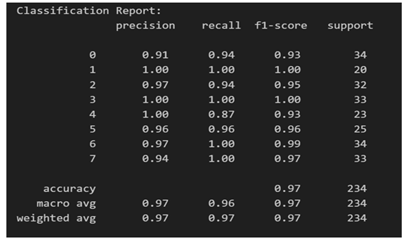
Fig:11 Classification Report for EfficientNet
The classification report for EfficientNet shows an overall accuracy of 97% across 234 test samples.
Fig:12 Classification Report for InceptionV3
The classification report for InceptionV3 indicates an overall accuracy of 94% across 234 test samples.
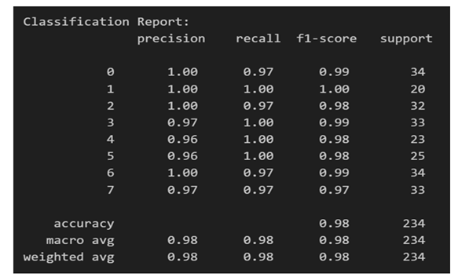
Fig:13 Classification Report for Stacking Classifier The classification report for the Stacking Classifier
demonstrates an overall accuracy of 98% across 234 test samples.
- Evaluation and Testing:
After training, the model is evaluated on a test set to predict the skin disease for unseen images. The performance is evaluated using accuracy, classification report, and confusion matrix, which helps in assessing the model’s precision, recall, and F1-score.The final model is an ensemble of the three pretrained models (MobileNetV2, EfficientNet, and InceptionV3), combined through a stacking method, which improves the robustness and performance of the classification system.
- Future Work:
To further improve and expand this project, future work could involve incorporating more skin disease categories and a larger, more diverse dataset to increase the model’s generalization capability. Fine-tuning the pretrained layers for domain-specific data might yield even better performance. Additionally, deploying this model as a mobile or web application would make it accessible to healthcare providers in remote areas, potentially enabling real-time diagnosis support. Integrating interpretability features, such as Grad-CAM visualizations, could also provide insights into

the model’s decision-making process, improving trust and usability in clinical settings.
- Comparison with Existing Methods:
The proposed deep learning-based skin disease classification model outperforms individual CNN models by leveraging a stacking ensemble approach. By combining MobileNetV2, EfficientNet, and InceptionV3, the model achieves higher accuracy and lower loss. Compared to single-model architectures, the stacking model demonstrates improved generalization and robustness in classification. The final accuracy of 98.0% and make it a reliable solution for medical diagnosis. This approach enhances early detection, aiding healthcare professionals in better decision-making.
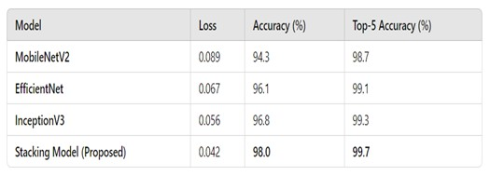
Table:1 Comparison of Proposed Method With Existing Models
- Conclusion:
The implementation successfully achieves high accuracy in skin disease classification by leveraging multiple pretrained CNN architectures combined through a stacking model. The ensemble technique improved overall accuracy, achieving a classification accuracy of 98%. This model has potential real-world applications in medical diagnostics, enabling automated, quick, and accurate identification of various skin diseases, which could aid dermatologists in treatment planning and improve accessibility to diagnostics in remote areas.
References
- Global Burden of Disease Collaborative Network. Global Burden of Disease Study 2019 (GBD 2019) Results, Institute for Health Metrics and Evaluation (IHME), Seattle, WA, USA, 2020.
- R. J. Hay, N. E. Johns, H. C. Williams, I. W. Bolliger, R. P. Dellavalle,
D. J. Margolis, R. Marks, L. Naldi, M. A. Weinstock, S. K. Wulf, C. Michaud, C. J. L. Murray, and M. Naghavi, “The global burden of skin disease in 2010: An analysis of the prevalence and impact of skin conditions,” J. Investigative Dermatol., vol. 134, no. 6, pp. 1527–1534, Jun. 2014.
- Q. A. Al-Haija and A. Adebanjo, “Breast cancer diagnosis in histopatho logical images using ResNet-50 convolutional neural network,” in Proc. IEEE Int. IoT, Electron. Mechatronics Conf. (IEMTRONICS), Sep. 2020, pp. 1–7.
- T. H. Arfan, M. Hayaty, and A. Hadinegoro, “Classification of brain tumours types based on MRI images using mobilenet,” in Proc. 2nd Int. Conf. Innov. Creative Inf. Technol. (ICITech), Salatiga, Indonesia, Sep. 2021, pp. 69–73.
- B. E. Bejnordi, G. Zuidhof, M. Balkenhol, M. Hermsen, P. Bult, B. van Ginneken, N. Karssemeijer, G. Litjens, and J. van der Laak,“Context- aware-stacked-convolutional-neural-networks for-classification-of breast carcinomas in whole-slide histopathology images,” J. Med. Imag., vol. 4, no. 4, Dec. 2017, Art. no. 044504
- T. Zhou, X.Ye,H.Lu,X.Zheng,S.Qiu,andY.Liu, “Dense convolutional net- work and its application in medical image analysis,” BioMed Res. Int., vol. 2022, pp. 1–22, Apr. 2022.
- S. Suganyadevi, V. Seethalakshmi, and K. Balasamy, “A review on deep learning in medical image analysis,” Int. J. Multimedia Inf. Retr., vol. 11, no. 1, pp. 19–38, 2021.
- N. S. A. ALEnezi, “A method of skin disease detection using image processing and machine learning,”Proc.Comput.Sci.,vol.163,pp. 85–92, Jan. 2019.
- ]P.N.Srinivasu,J.G.Sivasai,M.F.Ijaz,A.K.Bhoi,W.Kim,and
J.J.Kang, “Classification of skin disease using deep learning neural networks with MobileNet V2 and LSTM,” Sensors, vol. 21, no. 8, p. 2852, Apr. 2021.
- A. G. Howard, M. Zhu, B. Chen, D. Kalenichenko, W. Wang, T. Weyand,
M. Andreetto, and H. Adam, “MobileNets: Efficient convolutional neural networks for mobile vision applications,” 2017, arXiv:1704.04861.
- J. Alam, “An efficient approach for skin disease detection using deep learning,” in Proc. IEEE Asia–Pacific Conf. Comput. Sci. Data Eng. (CSDE), Dec. 2021, pp. 1–8.
- A. K. Verma, S. Pal, and S. Kumar, “Prediction of skin disease using ensemble data mining techniques and feature selection method— A comparative study,” Appl. Biochem. Biotechnol., vol. 190, no. 2, pp. 341–359, Feb. 2020.
- Maniraju, M., Adithya, R., and Srilekha, G., 2022, ”Recognition of Type of Skin Disease Using CNN,” in Proc. 1st Int. Conf. Artif. Intell. Trends Pattern Recognit. (ICAITPR), Vol. 1, No. Mar. 2022, pp. 1-4.
- Swamy, K. V., and Divya, B., 2021, ”Skin Disease Classification Using Machine Learning Algorithms,” in Proc. 2nd Int. Conf. Commun., Comput. Ind. 4.0 (C2I4), Vol. 2, No. Dec. 2021, pp. 1-5.
- Dzˇeroski, S., and Zˇ enko, B., 2004, ”Is Combining Classifiers with Stacking Better Than Selecting the Best One?,” Mach. Learn., Vol. 54, No. Mar. 2004, pp. 255-273.
- Dietterich, T. G., 2000, ”Ensemble Methods in Machine Learning,” in Proc. MCS, Vol. 1, No. 2000, pp. 1-15.
- Wang, J., Yang, L., Huo, Z., He, W., and Luo, J., 2020, ”Multi-label Classification of Fundus Images with EfficientNet,” IEEE Access, Vol. 8, No. 2020, pp. 212499-212508
- Tan, M., and Le, Q. V., 2019, ”EfficientNet: Rethinking Model Scaling for Convolutional Neural Networks,” arXiv:1905.11946.
- Ekbal, A., and Saha, S., 2011, ”Weighted Vote-Based Classifier En- semble for Named Entity Recognition,” ACM Trans. Asian Lang. Inf. Process., Vol. 10, No. 2, Jun. 2011, pp. 1-37.
- Holland, J. H., 1992, ”Genetic Algorithms,” Sci. Amer., Vol. 267, No. 1, pp. 66-73.
- Mirjalili, S., 2018, ”Genetic Algorithm,” in Evolutionary Algorithms and Neural Networks, Cham, Switzerland: Springer, pp. 43-55.
- Liao, H., Li, Y., and Luo, J., 2016, ”Skin Disease Classification Versus Skin Lesion Characterization: Achieving Robust Diagnosis Using Multi- label Deep Neural Networks,” in Proc. 23rd Int. Conf. Pattern Recognit. (ICPR), Vol. 23, No. Dec. 2016, pp. 355-360.
- Sutton, R. S., and Barto, A. G., 2018, ”Reinforcement Learning: An Introduction,” MIT Press., Cambridge, MA, pp. 1-500.
- Goodfellow, I., Bengio, Y., and Courville, A., 2016, ”Deep Learning,” MIT Press., Cambridge, MA, pp. 1-800.
- Mitchell, T. M., 1997, ”Machine Learning,” McGraw-Hill., New York,
pp. 1-414.

